**Contrast Stretching**

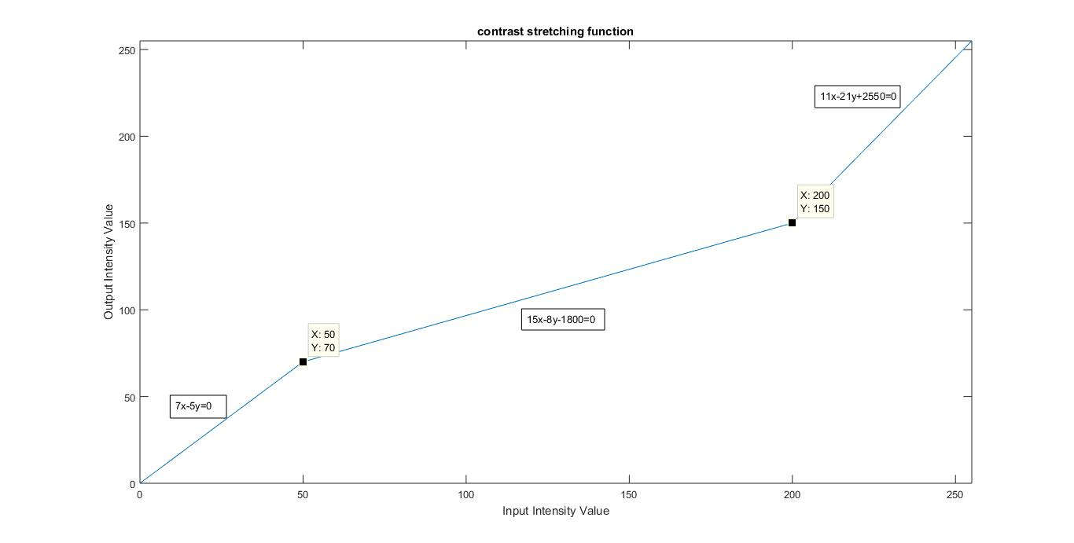

* Image is transformed by transformation function as shown in the graph above(x denotes a and y denotes b here):

b=(7*a)/5 if a<50

b=(15*a+1800)*8 if a>=50 and a<200

b=(11*a+2550)/21 if a>=200 and a<=255

where

a is every pixel of original image

b is pixel of output image

